Page |

1



**ASSIGNMENT**

**Assignment no - 01**

Course NO

Course Name

Submission Date

:

:

:

**Submitted To**

**Name: Khan Md. Hasib**

Assistant Professor

Department of Computer Science & Engineering

**Submitted By**

**Name: Junayet Hossain**

**ID:22234103154 INATKE:50**

**SECTION: 07**

24 January, 2023

Object Oriented Programming Language

CSE-121

1. Write a C++ program to find out first n perfect number where n is the input from user.

#include<iostream>

using namespace std;

int main()

{

int num, i, sum=0;

cout<<"Enter a Number: ";

cin>>num;

for(i=1; i<num; i++)

{

if(num%i==0)

sum = sum+i;

}

if(num==sum)

cout<<endl<<num<<" is a Perfect Number.";

else

cout<<endl<<num<<" is not a Perfect Number.";

cout<<endl;

return 0;

}

Output:

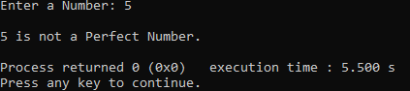

2. Write a C++ program to find first n Fibonacci number where n is the input from user.

#include <iostream>

using namespace std;

int main() {

int n, t1 = 0, t2 = 1, nextTerm = 0;

cout << "Enter the number of terms: ";

cin >> n;

cout << "Fibonacci Series: ";

for (int i = 1; i <= n; ++i) {

// Prints the first two terms.

if(i == 1) {

cout << t1 << ", ";

continue;

}

if(i == 2) {

cout << t2 << ", ";

continue;

}

nextTerm = t1 + t2;

t1 = t2;

t2 = nextTerm;

cout << nextTerm << ", ";

}

return 0;

}

Output:

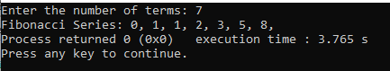

3. Write a C++ program to print out all Armstrong numbers between 1 and 10000. If sum of cubes of each digit of the number is equal to the number itself, then the number is called an Armstrong number.

#include <iostream>

#include <cmath>

using namespace std;

int main() {

int num1=1, num2= 10000, i, num, digit, sum, count;

if (num1 > num2) {

num1 = num1 + num2;

num2 = num1 - num2;

num1 = num1 - num2;

}

cout << "Armstrong numbers between " << num1 << " and " << num2 << " are: " << endl;

for(i = num1; i <= num2; i++) {

count = 0;

num = i;

while(num > 0) {

++count;

num /= 10;

}

sum = 0;

num = i;

while(num > 0) {

digit = num % 10;

sum = sum + pow(digit, count);

num /= 10;

}

if(sum == i) {

cout << i << ", ";

}

}

return 0;

}

Output:

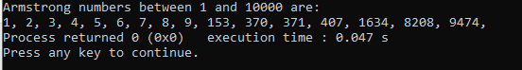

4. Write a function which receives a float and an int from main(), finds the product of  
these two and returns the product which is printed through main() in C++.

#include <iostream>

using namespace std;

int main() {

double num1, num2, product;

cout << "Enter two numbers: ";

// stores two floating point numbers in num1 and num2 respectively

cin >> num1 >> num2;

// performs multiplication and stores the result in product variable

product = num1 * num2;

cout << "Product = " << product;

return 0;

}

Output:

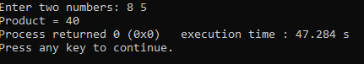

5.BUBT grading policy is :  
  
(i) 80 % marks or above is A+  
(ii) 75% to 79% marks is A  
(iii) 70% to 74% marks is A-  
(iv) 65% to 69% marks is B+  
(v) 60% to 64% marks is B  
(vi) 55% to 59% marks is B-  
(vii) 50% to 54% marks is C+  
(viii) 45% to 49% marks is C  
(ix) 40% to 44% marks is D  
(x) Below 40% is F  
  
Write a C ++ program which will take an input from user and calculate the grade of a student  
according to BUBT grading policy based on that input.

#include <iostream>

using namespace std;

int main(){

int marks;

cout<<"Enter Your Marks: ";

cin>>marks;

if (marks >= 80){

cout<<"Your Grade is A+";

}

else if (marks >= 75){

cout<<"Your Grade is A";

}

else if (marks >= 70){

cout<<"Your Grade is A-";

}

else if (marks >= 65){

cout<<"Your Grade is B+";

}

else if (marks >= 60){

cout<<"Your Grade is B";

}

else if (marks >= 55){

cout<<"Your Grade is B-";

}

else if (marks >= 50){

cout<<"Your Grade is C+";

}

else if (marks >= 45){

cout<<"Your Grade is C";

}

else if (marks >= 40){

cout<<"Your Grade is D";

}

else if (marks <= 39){

cout<<"Your Grade is F";

}

else{

cout<<"Enter Valid Marks";

}

return 0;

}

Output:

